
NOTE: This is an official document by Indexademics. Unless otherwise stated, this document may not be accredited to individuals or groups other than the club IDX, nor should this document be distributed, sold, or modified for personal use in any way.
IDX G9 Physics S+ STUDY GUIDE ISSUE 8
By Ziyu Pan and Aiden Zhan, Edited by Allison

Contents:
- 6-1 Work Done by a Constant Force
- 6-2 Work Done by a Varying Force
- 6-3 Kinetic Energy and the Work-Energy Principle
- 6-4 Potential Energy
- 6-5 Conservative and Nonconservative Forces
- Answers to “Check Your Understanding”

6-1 Work Done by a Constant Force
- Work (Scalar): The product of the magnitude of the displacement times the components of the force parallel to the displacement.
  - Unit: Joule (J)
  - $W = Fd cos θ$
- Positive Work: Force and displacement in same direction.
- Negative Work: Force opposes displacement.
- Examples:
- A sailor pulls a boat a distance of 0.30 m along a dock using a rope that makes a 25.0 0 angle with the horizontal. How much work does the sailor do on the boat if he exerts a force of 255 N on the rope? (pulling a crate with a rope at an angle)
$W = Fd cosθ=225N × 0.30m ×cos(25°)=69J$
  - Lifting an object vertically (work equals the change in gravitational potential energy)
Check Your Understanding:
Which of the following results in zero work?
A. Pushing a box across the floor
B. Holding a book without moving it
C. Pulling a sled in the snow
D. Dropping an object from a height

6-2 Work Done by a Varying Force
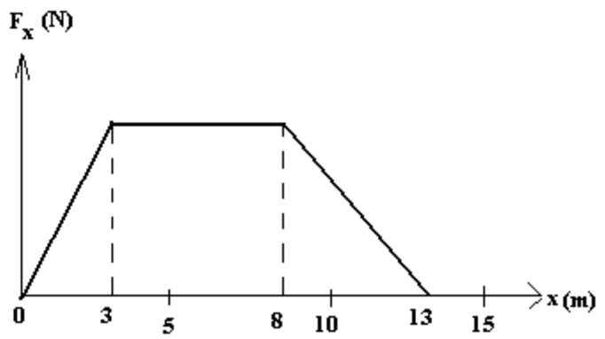
- Work from Area Under Force vs. Displacement Curve:
  - When force changes with position, work is found by calculating the area between the F and the x-axis.
  - For linear variation, this area is the area of a triangle or trapezoid.
  - Integration: $W=∫F(x) dx$
Check Your Understanding:
What does the area under a Force vs. Position graph represent?
A. Velocity
B. Acceleration
C. Work
D. Power

6-3 Kinetic Energy and the Work-Energy Principle
- Kinetic Energy (KE): Energy of motion, $KE=\frac{1}{2}mv^{2}$
- Work-Energy Principle: Net work = change in KE
$W_{net}=∆KE=\frac{1}{2}mv_{f}^{2}-\frac{1}{2}mv_{i}^{2}$
- Examples:
- A 145-g baseball is thrown so that it acquires a speed of 25 $m/s$
- What is its kinetic energy?
$KE=\frac{1}{2}mv^{2}= \frac{1}{2} × 0.145 × {25}^{2}≈45J$
- What was the net work done on the ball to make it reach this speed, if it started from rest?
$W=∆KE=45J-0J=45J$
Check Your Understanding:
If net work on an object is positive, what happens to its kinetic energy?
A. It decreases
B. It stays the same
C. It becomes zero
D. It increases

6-4 Potential Energy
- Potential Energy (PE): Stored energy due to position.
Gravitational: $PE=mgh$
Spring: $PE=\frac{1}{2}kx^{2}$
- Reference Point: PE is relative to chosen zero level.
- Examples:
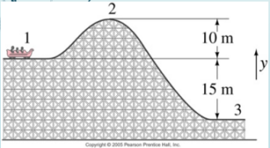
- A 1000-kg roller-coaster car moves from point 1 to point 2 and then to point 3.
- What is the gravitational potential energy at 2 and 3 relative to point 1? (Take y = 0 at point 1)

${PE}_{2}=mgh_{2}=1000×9.8×10=9.8×{10}^{4}$J
${PE}_{3}=mgh_{3}=1000×9.8×(-15)=-1.47×{10}^{5}$J
- What is the change in potential energy when the car goes from point 2 to point 3?
$∆PE={PE}_{3}-{PE}_{2}= -1.47×{10}^{5}J-9.8×{10}^{4}$J =$-2.45×{10}^{5}$J
- Repeat part (a) and (b) but take the reference point (y=0) to be at point 3.
${PE}_{2}^{'}=mgh_{2}^{'}=1000×9.8×25=2.45×{10}^{5}$J
${PE}_{3}^{'}=mgh_{3}^{'}=×$ $9.8$ $×$ 0 = 0J
$∆{PE}^{'}={PE}_{3}^{'}-{PE}_{2}^{'}= -2.45×{10}^{5}$J
- A spring has a spring stiffness constant of 440 N/m. How much must this spring be stretched to store 25 J of potential energy?
${PE}_{e}=\frac{1}{2}kx^{2}$
$∴x=\sqrt{\frac{2{PE}_{e}}{k}}=\sqrt{\frac{2×25}{440}}≈0.34m$
Check Your Understanding:
Which of the following increases an object’s gravitational potential energy?
A. Lowering it to the ground
B. Compressing a spring
C. Raising it to a higher shelf
D. Sliding it on a level surface

6-5 Conservative and Nonconservative Forces
- Conservative Force: Work is path-independent (e.g. gravity).
- Nonconservative Force: Work depends on path (e.g. friction).
- Conservation: Total mechanical energy conserved if only conservative forces act.
- Identifying Type: If potential energy can be defined, the force is conservative
- Example: A box sliding down a ramp with friction loses mechanical energy due to friction
Check Your Understanding:
Which of the following is a conservative force?
A. Friction
B. Tension
C. Gravity
D. Air Resistance

Answers to “Check Your Understanding”
- 6-1: B
- 6-2: C
- 6-3: D
- 6-4: C
- 6-5: C

